Name: Hunar Katyal
UID:24BDA70085
Batch: 24Ait-KRG-G2

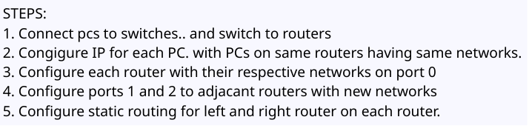
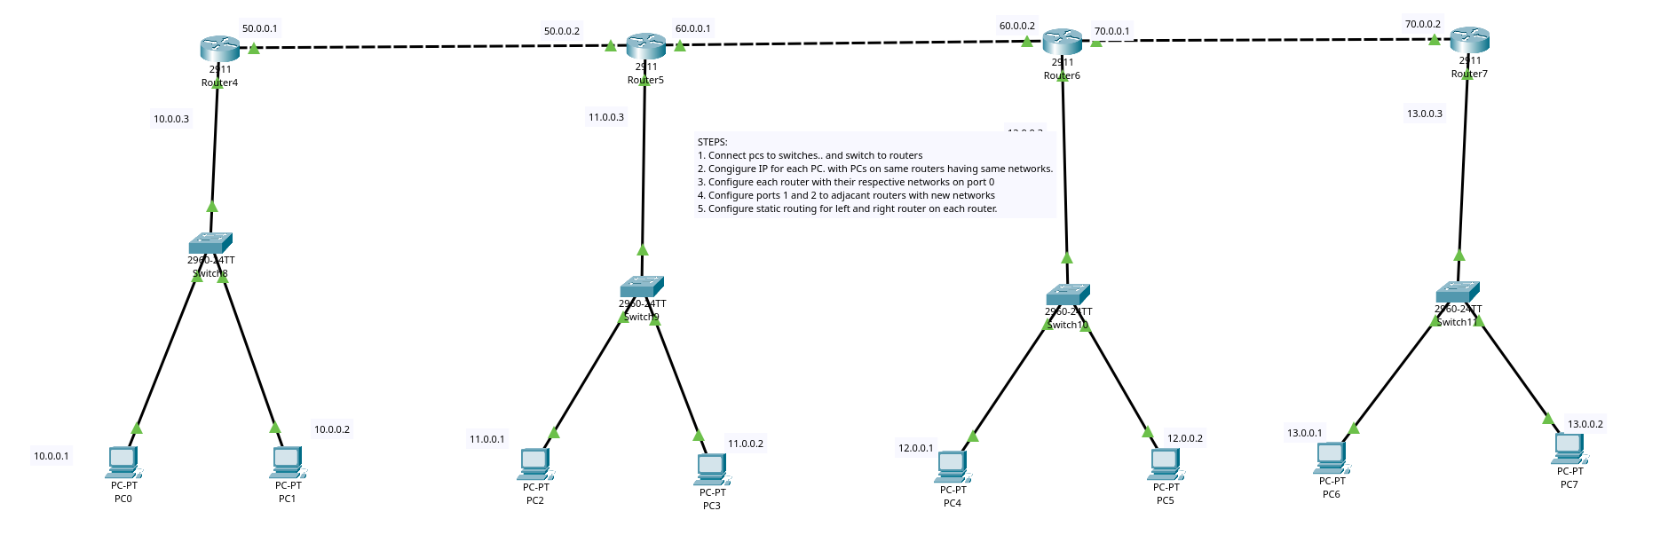
Q1

Q2
